1. Read the question and the student’s answer carefully.
2. Use the mark scheme to award the student a number of marks and annotate their answer with suggestions to improve.
Stretch: Rewrite the answer to show how it should be done!

Question:
The table below gives some information about some of the fractions in crude oil.
Fraction | Length of hydrocarbons (number of carbon atoms) | % in crude oil | % demand
Gas | 1-4 | 3 | 14
Petrol | 5-8 | 7 | 26
Kerosene | 9-15 | 12 | 18
Diesel | 16-24 | 24 | 20
Bitumen | >25 | 54 | 22

- The quantity of each fraction can be changed by cracking.
Describe what happens when a hydrocarbon is cracked and the conditions required.
(4)
- Use information from the table to explain why cracking is useful. (3)
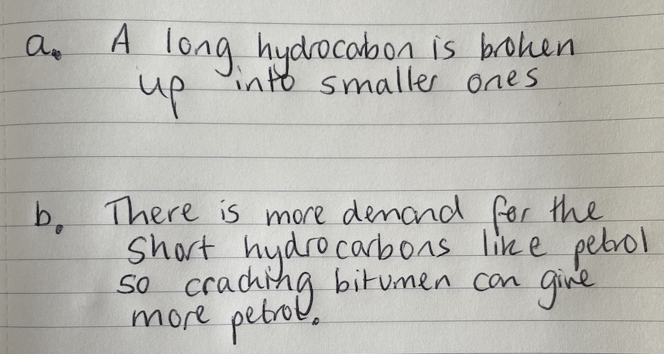
Student answer:

Marks awarded= _______
Mark scheme:

Point | Mark
Long/large hydrocarbon chains are broken down | 1
Into shorter chain hydrocarbons (alkanes) | 1
And alkenes | 1
A high temperature or catalyst is required | 1

Point | Mark
There is higher demand than supply of short chains (from crude oil) | 1
So cracking can increase the supply of short chain hydrocarbons | 1
Named example,  e.g. only 7% of crude oil is petrol but it is over a quarter of the demand, so producing more petrol through cracking can meet this demand | 1

